<Genealogy>
Design Document
Version <1.0>

INSTRUCTOR | LEVENT AKIN
STUDENT | EMİN ŞENAY
STUDENT ID | 2002103907
YEAR | 2004/2nd TERM

Revision History
Date | Version | Description | Author
<25/05/2004> | <1.0> | <Main SDD> | <Emin Şenay>

Table of Contents
1. Introduction 4
1.1 Purpose 4
1.2 Scope 4
1.3 Definitions, Acronyms, and Abbreviations 5
1.4 References 5
1.5 Overview 5
2. Software Interface Design 5
2.1 User Interface 5
2.2 Dynamic Models of System Interface 6
3. Internal Module Design 7
3.1 Class Diagram 7
3.2 Class Descriptions 7
3.2.1 Class <Operations> 7
3.2.1 Class <TreeList> 10
3.2.1 Class <Person> 13
3.2.1 Struct <Family> 15
3.2.1 Struct <Properties> 16
3.2.1 Struct <Listnode> 16
4. Flow Diagram 16

Design Document

Introduction

Purpose
This software document is prepared to explain the CMPE 160 PROJECT #5 “Genealogy”, so people who is interested in modifying or inspecting the program can easily get related data and can easily understand the detailed design of the program.
The purpose of this document is to provide all details of the Software Interface Design (SID), and Internal Module Design (IMD) for Genealogy. The SID focuses on the user interfaces and the high-level module interfaces, and the IMD focuses on the low-level description of the implementation classes and all their attributes and methods.

Scope
This document is about a Genealogy program. Program must understand and give following responses to the following commands:

MALE <name> EXISTS: | <name> is a male, but we know nothing about his parentage. Program should create a new node including gender and name.
FEMALE <name> EXISTS: | <name> is a female, but we know nothing about her parentage. Program should create a new node including gender and name.
<name1> AND <name2> BEGET SON <name3>: | <name1> is a male and <name2> is a female. These names have already been defined by an EXISTS or BEGET command. Moreover, <name1> and <name2> should be associated with MARRIES command. <name3> is a male. Program should create a new node including gender, name and parentage informations.
<name1> AND <name2> BEGET DAUGHTER <name3>: | <name1> is a male and <name2> is a female. These names have already been defined by an EXISTS or BEGET command. Moreover, <name1> and <name2> should be associated with MARRIES command. <name3> is a female. Program should create a new node including gender, name and parentage informations.
<name1> MARRIES<name2>: | <name1> and <name2> are people of the opposite sex and  neither is already married. Either<name1> or <name2> may be the male, however. Both <name1> and <name2> have already been defined by an EXISTS or BEGET command. Program should store the marriage information.
PRINT <name>'S <relationship>: | All of <name>'s relatives satisfying the given relationship are to be printed in any order. <name> has already been defined by an EXISTS or BEGET command. <Relation> may be any of the following words: SIBLINGS, SISTERS, BROTHERS, CHILDREN, DAUGHTERS, SONS, PARENTS, GRANDPARENTS, AUNTS, or UNCLES. If any of the information requested by a PRINT command is not known, the phrase "unknown" should be printed. If <name> has no relatives satisfying thespecified relation, nothing need be printed.
QUIT: | Save the family information to the "Family.dat" file, and terminate the program.

All these commands and responses should be saved to “Families.trn” text file. In addition, commands of the new session and responses of them should be printed to screen.

Definitions, Acronyms, and Abbreviations

References
C How to Program, Deitel&Deitel, 3rd Edition
C++ Plus Data Structures, Nell Dale, 3rd Edition
http://www.cplusplus.com

Overview
The remaining parts of this document are designed as following: Second part of the design document will be about the software interface design. The program will be explained using user interface and sequence diagrams. Part 3 is about internal module design and contains class diagrams and detailed information about classes. Part 4 contains the flow diagram of the software.

Software Interface Design

User Interface
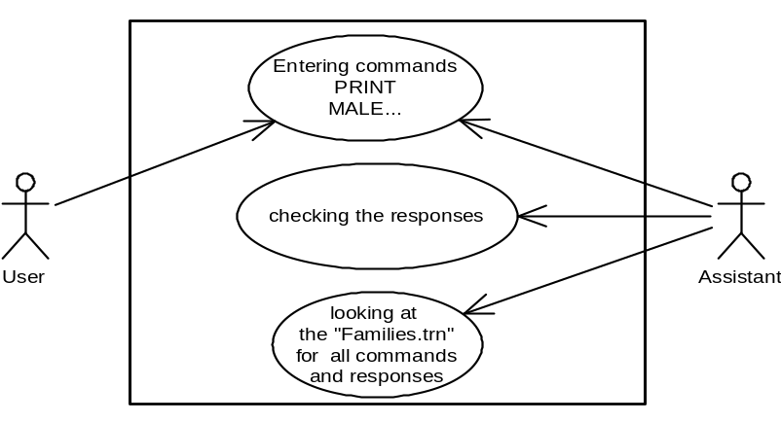

Dynamic Models of System Interface
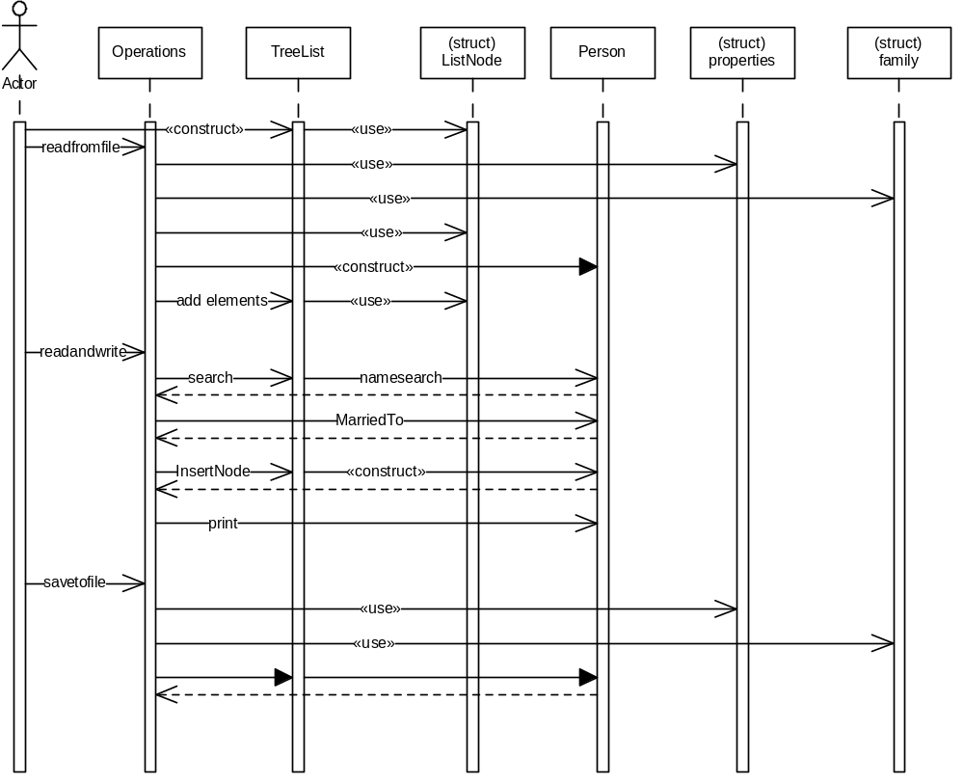

Internal Module Design

Class Diagram
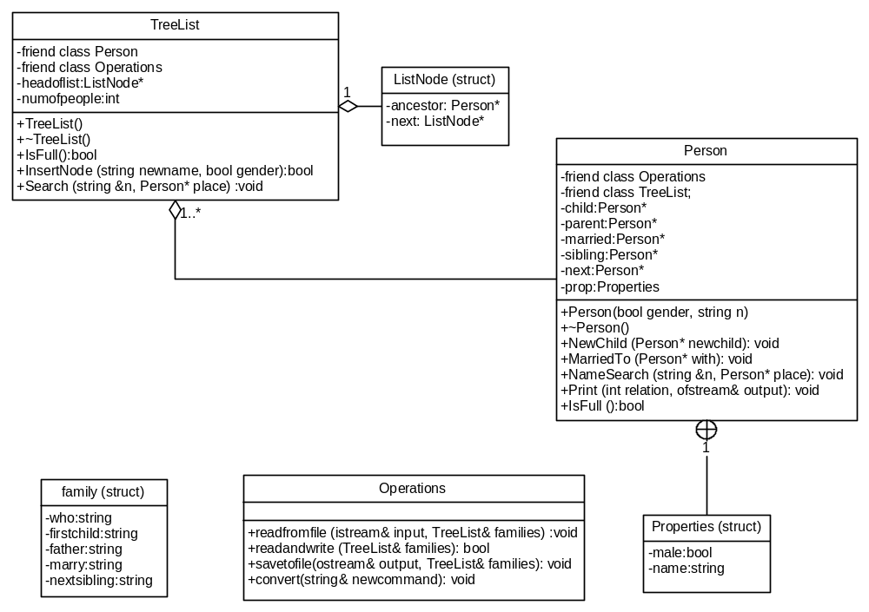

Class Descriptions

Class <Operations>
3.2.1 | Operations
 | 3.2.1.1 | Class decomposition
 |  |  | Inherited classes: -
 |  |  | Aggregated classes: -
 |  |  | Associated classes: TreeList
 |  |  | Data members: -
Member functions:
void readfromfile (istream& input, TreeList& families): Reads trees from the file and constructs the family list.
bool readandwrite(TreeList& families): Takes commands from the user and responses them. It also writes commands and responses to file.
void savetofile(ostream& output, TreeList& families): Saves trees to the file.
void convert(string& newcommand): Takes strings and converts them to the appropriate case structure for the other functions of the class.
 | 3.2.1.2 | Function Decomposition
 |  |  | Function Name: readfromfile
 |  |  | Return Type: void
 |  |  | Input parameter: istream& input
 |  |  | Output parameter: TreeList& families
 |  |  | Files accessed: “Family.dat”
 |  |  | Files changed: None
 |  |  | Caller: main()
 |  |  | Pre: Name of the people cannot be “None”.
 |  |  | Post: Tree structure from the past executions of the program is constructed.
 |  |  | Algorithm (Description in pseudo-code): First, take the number of tree nodes. Then take the name and gender information of all persons. Construct all of the tree nodes and bind them with their next link. Then take the link information of all of the people (i.e. names of the people who are linked). Find the link places by comparing the taken name information with the names of nodes. When found, simply link them with appropriate links of the node. If any of the name field you read is “None”, do not change the initial values (NULL) of the links. In addition, when the parent link is “None”, create a new ListNode and set its ancestor to the person you read. (The new ListNode we created is for searching.)
 |  |  | Function Name: readandwrite
 |  |  | Return Type: bool
 |  |  | Input parameter: TreeList& families
 |  |  | Output parameter: TreeList& families
 |  |  | Files accessed: Family.trn
 |  |  | Files changed: Family.trn
 |  |  | Caller: main()
 |  |  | Pre: Trees should be constructed.
 |  |  | Post: Commands are taken and their response is written and done by the function. In addition, commands and responses are saved to “Family.trn” text file.
 |  |  | Algorithm (Description in pseudo-code): Try to open the “Family.trn” with append. If unsuccessful, return 0. Else, take the command from the screen. Separate words and send the first word to the convert function. Then, inspect the command. The first word of the command can be “Male, Female, Print, Quit or <Name>.). If it is Male or Female, send the other words to convert function. Then search the name with which the user wants to create the new person with TreeList::Search function. If you find the name on the existing tree, give an error message. Else, create a new node with the given information with TreeList::InsertNode function. If the fist word is Quit, return 1. If the first word is Print, search the name entered in existing trees. If not found, give a response. Else, the third word can be Brothers, Sisters, Parents, Uncles, Aunts, Grandparents, Siblings, Sons, Daughters, Children, Father and Mother. Print the appropriate names with Person::Print function. If the first word is none of the above, it means it is a name. If it is a name, the possibilities of the remaining command is Marries <Name> and And <Name> Beget Son (Daughter) <Name>. First, search in existing trees the first name. If found, search the second name in trees. If the command is Marries, first check the gender of these two people. If their gender is same, give a response (people with same gender cannot be married in the program) Then, check if these people are married with each other. If they are already married, give a response. If not, send these people to Person::MarriedTo function. If the command is Beget, check the child’s name in the existing tree. If found, give a response. Else, create a new person with the given info and link it to the father with Person::child function. Increment number of people in all families with TreeList::IncrementPeople function.
 |  |  | Function Name: savetofile
 |  |  | Return Type: void
 |  |  | Input parameter: TreeList& families
 |  |  | Output parameter: ostream& output
 |  |  | Files accessed: Family.dat
 |  |  | Files changed: Family.dat
 |  |  | Caller: main()
 |  |  | Pre: All members of all trees should be linked.
 |  |  | Post: All of the family information is stored into the Family.dat file.
 |  |  | Algorithm (Description in pseudo-code): First, save the number of people in all of the trees. Then, save the name and gender information of all people. Lastly, save the names of people to which parent, sibling, marriage and child links are pointing.
 |  |  | Function Name: convert
 |  |  | Return Type: void
 |  |  | Input parameter: string& newcommand
 |  |  | Output parameter: string& newcommand
 |  |  | Files accessed: None
 |  |  | Files changed: None
 |  |  | Caller: readandwrite
 |  |  | Pre: -
 |  |  | Post: Given string is converted.
 |  |  | Algorithm (Description in pseudo-code): Convert the first letter of string to uppercase, and convert the remaining to lowercase.
 | 3.2.1.3 | Statechart
 | 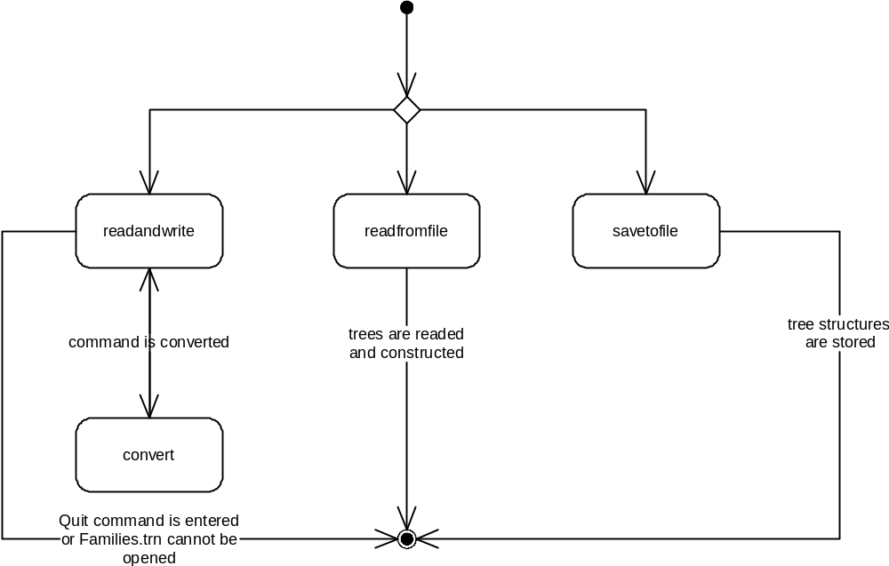

Class<TreeList>
3.2.2 | TreeList
 | 3.2.2.1 | Class decomposition
 |  |  | Inherited classes: -
 |  |  | Aggregated classes: -
 |  |  | Associated classes: Operations, Person
Data members:
ListNode* headoflist: points the head of the list.
int numofpeople: Counts the number of people in all of the families.
Member functions:
TreeList(): Constructor
~Treelist():Destructor
bool IsFull(): Checks if the memory is full or not.
bool InsertNode (string& newname, bool gender): Creates new node and a person.
void Search (string& n, Person& place): Searches the given string in list and its trees.
void IncrementPeople(): Increments the numofpeople by 1.
 | 3.2.2.2 | Function Decomposition
 |  |  | Function Name: TreeList
 |  |  | Return Type: None
 |  |  | Input parameter: None
 |  |  | Output parameter: None
 |  |  | Files accessed: None
 |  |  | Files changed: None
 |  |  | Caller: None
 |  |  | Pre: TreeList is not constructed.
 |  |  | Post: TreeList is constructed.
 |  |  | Algorithm (Description in pseudo-code): Create a new ListNode (header node). Set its ancestor and next to null. Set headoflist to this ListNode. Set numofpeople to 0.
 |  |  | Function Name: ~Treelist
 |  |  | Return Type: None
 |  |  | Input parameter: None
 |  |  | Output parameter: None
 |  |  | Files accessed: None
 |  |  | Files changed: None
 |  |  | Caller: None
 |  |  | Pre: Class should be constructed.
 |  |  | Post: Class is destructed.
 |  |  | Algorithm (Description in pseudo-code): Starting from the first ListNode, delete all the members of the tree to which ancestor is pointing, then delete the ListNode.
 |  |  | Function Name: IsFull
 |  |  | Return Type: bool
 |  |  | Input parameter: None
 |  |  | Output parameter: None
 |  |  | Files accessed: None
 |  |  | Files changed: None
 |  |  | Caller: InsertNode
 |  |  | Pre: Class should be constructed.
 |  |  | Post: We know that if there is enough memory for the new ListNode and Person.
 |  |  | Algorithm (Description in pseudo-code): Try creating a new node and a person. If successful, delete created nodes and return 0. Else (if you caught bad_alloc exception) return 1.
 |  |  | Function Name: InsertNode
 |  |  | Return Type: bool
 |  |  | Input parameter: string& newname, bool gender
 |  |  | Output parameter: None
 |  |  | Files accessed: None
 |  |  | Files changed: None
 |  |  | Caller: Operations::readandwrite
 |  |  | Pre: Class should be constructed.
 |  |  | Post: New node is created and new person with the given information is added to a new tree.
 |  |  | Algorithm (Description in pseudo-code): If memory is full, return false. Else, create a new ListNode and link it next to the first element of the TreeList. Create a new person with the given info and link newnode’s ancestor to this person. Increment the numofpeople by 1.
 |  |  | Function Name: Search
 |  |  | Return Type: void
 |  |  | Input parameter: string& n
 |  |  | Output parameter: Person& place
 |  |  | Files accessed: None
 |  |  | Files changed: None
 |  |  | Caller: Operations::readandwrite
 |  |  | Pre: Class should be constructed.
 |  |  | Post: If found, place links the person’s location. Else, place is set to NULL.
 |  |  | Algorithm (Description in pseudo-code): Set place to NULL. Beginning from the second ListNode, search the ancestor’s trees by Person::NameSearch function up to the last ListNode. If found, stop searching and return the location of person.
 |  |  | Function Name: IncrementPeople
 |  |  | Return Type: void
 |  |  | Input parameter: None
 |  |  | Output parameter: None
 |  |  | Files accessed: None
 |  |  | Files changed: None
 |  |  | Caller: InsertNode and Operations::readandwrite
 |  |  | Pre: Class should be constructed.
 |  |  | Post: Number of people is incremented by 1.
 |  |  | Algorithm (Description in pseudo-code): Increment numofpeople by 1.
 | 3.2.2.3 | Statechart
 | 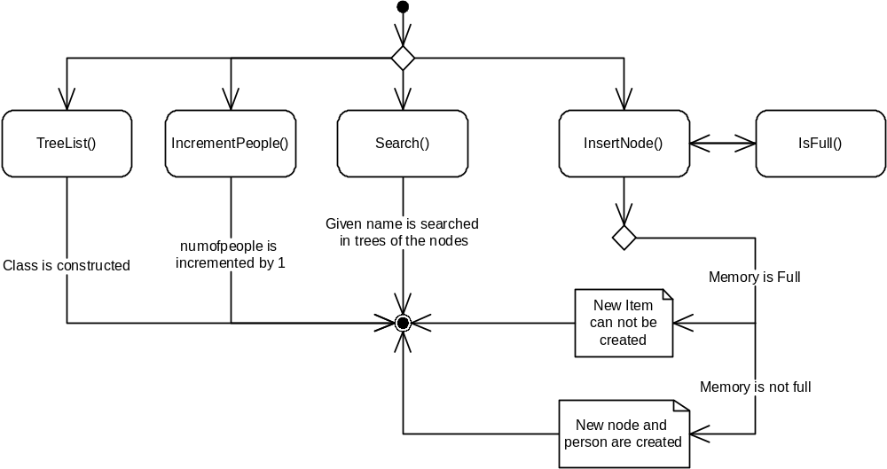

Class <Person>
3.2.3 | Person
 | 3.2.3.1 | Class decomposition
 |  |  | Inherited classes: None
 |  |  | Aggregated classes: TreeList
 |  |  | Associated classes: Operations
Data members:
Person* child: link to the child node.
Person* parent: Link to the father.
Person* married: Link to the partner.
Person* sibling: Link to first sibling.
Properties prop: Name and gender information.
Person* next: Next person.
Member functions:
Person(bool gender, string n): Constructor.
~Person(): Default destructor.
void NewChild (Person* newchild): Adds a new child.
void MarriedTo (Person* with): Used to set the link to married person.
void NameSearch (string &n, Person* place): Searches the given name in the tree.
void Print (int relation, ofstream& output): Prints the given relationship of the person.
bool IsFull(): Checks whether memory is full or not.
 | 3.2.3.2 | Function Decomposition
 |  |  | Function Name: Person
 |  |  | Return Type: None
 |  |  | Input parameter: bool gender, string n
 |  |  | Output parameter: None
 |  |  | Files accessed: None
 |  |  | Files changed: None
 |  |  | Caller: None
 |  |  | Pre: None
 |  |  | Post: A person with given information is created.
 |  |  | Algorithm (Description in pseudo-code): If memory is not full, create a new person and set male info to gender, set name information to n. Set all of the links to NULL.
 |  |  | Function Name: NewChild
 |  |  | Return Type: void
 |  |  | Input parameter: Person* newchild
 |  |  | Output parameter: None
 |  |  | Files accessed: None
 |  |  | Files changed: None
 |  |  | Caller: Operations::readandwrite
 |  |  | Pre: Class should be constructed.
 |  |  | Post: New child is added to the given person.
 |  |  | Algorithm (Description in pseudo-code): If child pointer is NULL, link child to the person’s child link. Else, traverse to the last child and link the new child to last child’s sibling link. Set next pointer of the new child.
 |  |  | Function Name: MarriedTo
 |  |  | Return Type: void
 |  |  | Input parameter: Person* with
 |  |  | Output parameter: Person* with
 |  |  | Files accessed: None
 |  |  | Files changed: None
 |  |  | Caller: Operations::readandwrite
 |  |  | Pre: Class should be constructed
 |  |  | Post: Given people are married.
 |  |  | Algorithm (Description in pseudo-code): Set the married link to with, set with’s married link to this.
 |  |  | Function Name: NameSearch
 |  |  | Return Type: void
 |  |  | Input parameter: string &n
 |  |  | Output parameter: Person* place
 |  |  | Files accessed: None
 |  |  | Files changed: None
 |  |  | Caller: TreeList::Search
 |  |  | Pre: Class should be constructed.
 |  |  | Post: If given name is found, place is pointing to the node of the given name. Else, place is pointing to NULL.
 |  |  | Algorithm (Description in pseudo-code): Set place to NULL. If name is the equal to the given name, set place pointer to this. Else, first search in the child nodes if child pointer is not NULL. If name cannot be found there, search in the sibling nodes if sibling pointer is not NULL.
 |  |  | Function Name: Print
 |  |  | Return Type: void
 |  |  | Input parameter: int relation
 |  |  | Output parameter: ofstream& output
 |  |  | Files accessed: Family.trn
 |  |  | Files changed: Family.trn
 |  |  | Caller: Operations::readandwrite
 |  |  | Pre: Class should be constructed.
 |  |  | Post: given relationship is printed both to screen and to file.
 |  |  | Algorithm (Description in pseudo-code): Switch the relation number. (1:Sibling, 2:Sister, 3:Brother, 4:Children, 5:Daughter, 6:Son, 7:Parent, 8:Grandparent, 9:Aunt, 10:Uncle) Find the appropriate relative of the person with the sibling, parent, married and child links. Print them to screen and file.
 |  |  | Function Name: IsFull
 |  |  | Return Type: bool
 |  |  | Input parameter: None
 |  |  | Output parameter: None
 |  |  | Files accessed: None
 |  |  | Files changed: None
 |  |  | Caller: Person
 |  |  | Pre: Class should be constructed.
 |  |  | Post: We know that if there is enough memory for the new ListNode and Person.
 |  |  | Algorithm (Description in pseudo-code): Try creating a new person. If successful, delete created nodes and return 0. Else (if you caught bad_alloc exception) return 1.
 | 3.2.3.3 | Statechart
 | 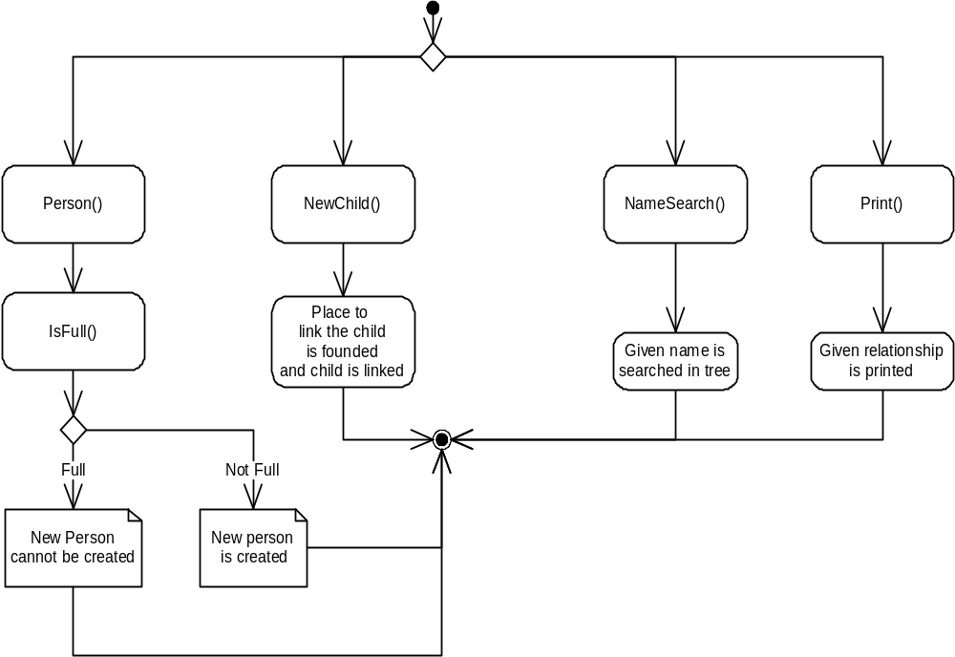

Struct <family>
3.2.4 | family
 | 3.2.4.1 | Struct decomposition
 |  |  | Inherited classes: -
 |  |  | Aggregated classes: -
 |  |  | Associated classes: Operations
Data members:
string who: Name of the person
string firstchild: Name of the first child
string father: Name of the father
string marry: Name of the partner
string nextsibling: Name of the next sibling

Struct <Properties>
3.2.5 | Properties
 | 3.2.5.1 | Struct decomposition
 |  |  | Inherited classes: -
 |  |  | Aggregated classes: -
 |  |  | Associated classes: Person
Data members:
bool male: Gender
string name: Name

Struct <ListNode>
3.2.6 | ListNode
 | 3.2.6.1 | Struct decomposition
 |  |  | Inherited classes: -
 |  |  | Aggregated classes: TreeList
 |  |  | Associated classes: -
Data members:
Person* ancestor: The root of the tree
ListNode* next: Link to the next element.

Flow Diagram